

NOVAC TECHNOLOGY SOLUTIONS

User Manual

Document Version No.: 1.00

Revision History
Version No | Reason For Changes | Author | Approver
0.01 | Draft | Ravi
1.00 | Reviewed & Approved the User Manual | Ravi | NIJANTHAN PL

Table of Contents
1. Introduction 4

2. Premium recived date and commission paid date 4

Introduction

The document is prepared to understand the reports generated in ZIVA application. This document is being prepared in reference to,
- Guidelines, circulars, instructions and directions released from time to time by Philippines Insurance council.

Functional Overview

System should have the provision to generate the Premium received date and commission paid date report for all products.

Premium received date and commission paid date

System should have the provision to generate the Premium received date and commission paid Report based on the input parameters. System should generate the report in “.xls” format.

Search the Mis Report Screen.

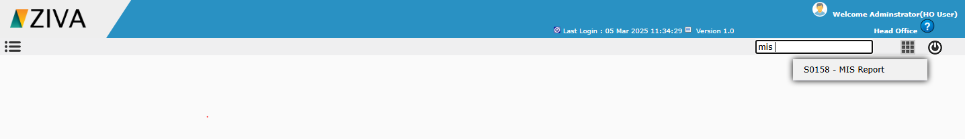

Click on the Premium received date and commission paid date Screen. System will display the Report details tab.

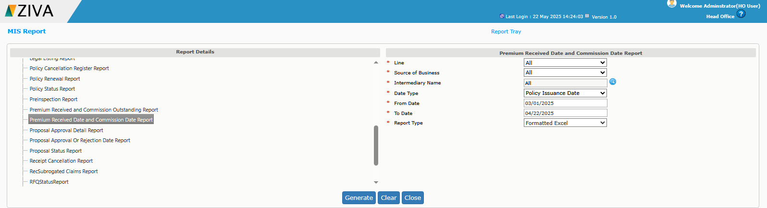

Enter all the required details and click the Generate button. The report will be generated and can be downloaded from the Report Tray.

